BROWARD COUNTY
North Area Advisory Council Steering General Meeting
 | LOCATION: Virtual
Meeting Date: 4/22/2021

Committee Members: See attendance

Guest(s):
Item | Discussion | Action & Follow-up
Item #1  Welcome | - Meeting called to order 6:33 pm
Item #2  Minutes | - Minutes from March meeting are unavailable
Item #3  New Website | - http://northareaadvisorycouncil.ch2v.com/  - Please register on this website to receive all NAAC emails | Contact Info:  Jeff Bold  jeff.bold@stylemyown.com  954-612-5097
Item #4  Donna Boruch | - Customer Survey  - Accreditation in October / 5 year accreditation /
Item #5  Scott Jarvis | Accreditation visit in Orange County School  Thank you for patience and perseverance for advisory meetings
Item #6  Richie Baum | - Emergency order for the State of Florida issued 4/9/2021  - Information available Broward schools.com/testing  - Emergency order – remove high stakes consequences  - Teacher Evaluation are still tied to student assessment  - Promotion criteria explained  - Browardschools.com/testing | Richie Baum  Director  Student assessment and Research  Richard.baum@browardschools.com
Item #7  Nathalie Lynch-Walsh | - Blanche Ely – no cover for the bus loop / Cost of work /  Directive to complete work is delayed with Superintendent  - NEHS – Building behind by 7 months  - Rickards Middle meets the criteria to demolish the building by the state  If building is demolished, students would attend NEHS / local elementary schools  Currently the students are at Broward College  No timeline for students to return to building at Rickards Middle School | Natalie Lynch-Walsh, Ph.D.  Facilities Task Force Chair  BCBS – Smart futures  Sent e-mails to Jeff.bold@stylemyown.com  He will forward the email to Mrs. Lynch-Walsh
Item #8  Tom Albano | - Summer School sign up for enrichment and elective courses  - Various training including FAFSA  - College Signing Day for Athletes, Academics, Military, Career Ready 4/30/21 | Ralph Aiello  Director  School Counseling & BRACE
Item #9  Ralph Aiello | - Culturally response Instructional Leadership – Training  - Various training for students, educators, and volunteers addressing gender, race, social equity, etc.  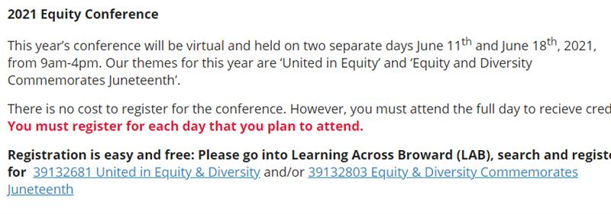 | Tom Albano  Equity & Diversity Department
Item #10  New Business | - Sent through email blast  - Questions regarding SAC training | SAC Survey
Item #11  New Business | - Florida Department of Education issues emergency order  - http://www.fldoe.org/newsroom/latest-news/florida-department-of-education-issues-emergency-order.stml

Item #12  New Business | - Superintendent Runcie announces All students will return for 2021/2022  - https://eduvision.tv/l?emmyetO | Jeff Bold  jeff.bold@stylemyown.com  954-612-5097

Item #13  Old Business | - Election Candidate Committee – Jeff Bold has reached term limit  - Elections will be held at an in person meeting | Scott Jarvis

Item #13  Announcements | Speakers for May John Sullivan, Angel Gomez, and others | Scott Jarvis

Item #14 | Adjournment 8:34 PM  Motion to close meeting  Next North Area Advisory Meeting – 5/20/2021 @ 6:30 PM Virtual Teams  Next District Advisory Meeting – 5/12/2021 @ 6:30 PM Virtual Teams

Respectfully Submitted,
Roshana Parris

